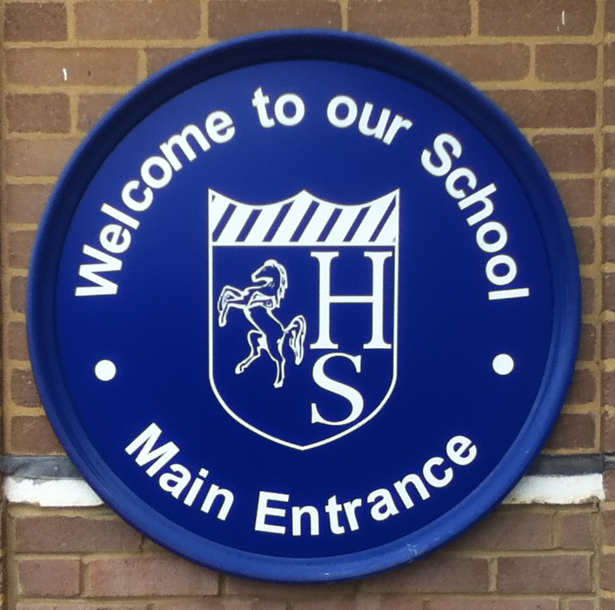

If there is any information you need that isn’t provided in this booklet, our school website (www.hillsgrove.apat.org.uk) has very detailed information of all aspect of school life.

Contents

School Opening Times
Uniform
Food and drink
Communication
Parent involvement
Attendance

School Opening Times

Reception children will enter via the Plymstock Road entrance between 8.30 and 8.45am, when the gate shuts. Our new families will have separate communication with regards to this as part of the induction process. Our children independently enter the classroom and have set routines at the start of each day to make sure they are ready to learn. All children should be in the classroom by 8.45am. The usual timings of the school day are as follows:

Gates open | 8.30-8.45
Session 1 | 8.45-10.30
Break | 10.30-10.45
Session 2 | 10.45-11.30
Lunch | 11.45-12.45
Session 3 | 12.30-3.15pm
Home time | Doors open 3pm


Uniform

The Uniform consists of:
- Navy blue sweatshirt
- Navy blue cardigan
- Grey trousers or skirt
- Grey pinafore dress
- Light blue and white gingham dresses (during Summer)
- White polo shirt / shirt / blouses
- Grey, navy or black tights
- Grey, navy, black or white socks
- Black school shoes (not black trainers)
PE kit consists of:

- White t-shirt
- Navy shorts
- Navy tracksuit
- Plain white or black trainers (for outdoor PE)
- Black plimsolls (for indoor PE)

Please make sure that all uniform has your child’s name on it.

- For outdoor learning, children will also need a waterproof suit (or trousers/jacket) and wellington boots.

Food and drink

At Hillsgrove Primary School, our school dinners are freshly prepared and provided by The Pantry, offering nutritious and balanced meals every day. These meals are currently funded by the Mayor of London, allowing all children to enjoy a healthy lunch at no cost to families. Please note that we are a nut-free school to ensure the safety of all our pupils, so we kindly ask that no products containing nuts are brought onto the premises. Additionally, as part of the Government’s healthy eating initiative, all children from Nursery up to Year 2 receive free fruit each day to encourage healthy snacking habits.

Communication

At Hillsgrove, there are 2 apps that parents will need to download. When your child starts school, you will be sent all of the login details needed.


- My Child At School (MCAS)
Through the MCAS app, you can view your child’s attendance, update contact details, receive important messages from the school, book Parent’s Evening appointments, make payments for items such as school trips and clubs.

- Google Classroom
This is where homework can be accessed. Teachers also use Google Classroom to share photos of educational visits, examples of children’s work, and pictures of pupils taking part in a variety of activities. It’s a great way for parents to stay engaged with their child’s learning and school experiences.

Every class also has an email address so parents can communicate directly with teachers, who will respond within 48 hours: classname@hillsgrove.bexley.sch.uk for any urgent message, please email admin@hillsgrove.bexley.sch.uk

To gain an insight into school life at Hillsgrove, you can follow us on Instagram @hillsgroveprimarysch and we have our own Face Book page.

Parent Involvement

Parents and carers are welcome at Hillsgrove. We aim to work closely with parents and carers to support the children and ensure that they are happy and making progress. Members of staff are happy to discuss any aspect of the children’s work or behaviour. Parents/carers wishing to see a member of staff should make an appointment using the class email address or through the office admin@hillsgrove.bexley.sch.uk

Parent’s Evening are held twice a year-during the Autumn term and the Spring Term. These are a great opportunity to meet with the class teacher to look at your child’s learning and discuss progress. We also have Learning Celebrations where parents/carers are invited in during the school day to the classroom to look through all books, see your child’s learning environment and to celebrate your child’s learning. In addition to this, we also offer Phonics and Maths workshops.

Parents are also invited to support the school through:

-Joining the Parent/ Teacher Association
-Volunteering time to hear children read
-Speaking to your child’s class about your culture or career
-Volunteering to be a chaperone for educational visits

Attendance

It is our aim for every child to be in school every day. Of course, we know that this isn’t always possible, so we set out some guidance on keeping school informed of absence. This helps us check that all children are safe.

Term Dates

Dates for academic terms are published on the school website (www.hillsgrove.apat.org.uk/term-dates) at least 6 months before the start of each academic year.

Illness

If your child is too ill to attend school, please contact the school on the first and each subsequent day of absence on the school absence line before 8.45am. You can do this by telephoning 020 8303 4949.

If your child is suffering with diarrhoea and/or vomiting, please allow 48 hours after this has ceased.

If you’re unsure whether or not your children should attend, we suggest bringing them in and speaking with their class teacher or with the school office. We can always call home if they feel particularly unwell later in the day.

Medical Appointments

We always ask that you make routine appointments outside of school hours. If this is not possible or it is a hospital appointment, please bring in the appointment letter or card to the school office so we can make a copy and approve the absence.

Special Leave Requests for holidays/other term-time absence

Schools are not permitted to authorise holidays except in exceptional circumstances. If there are exceptional reasons why you would like to take your children out of school during term time, please request an application form from the school office. For further information, please follow the link below:

https://www.bexley.gov.uk/services/schools-and-education/school-attendance/education-welfare-service

