Amadeus Primary Academies Trust Curriculum, Teaching & Learning Policy

Rationale
Developments in our understanding of how children learn and research including Sweller’s cognitive load theory, Rosenshine’s principles of instruction guided by Cain and Oakhill’s vocabulary instruction and Fiorella and Mayer’s generative learning practice, have helped us as a Trust to develop a deeper understanding of effective teaching and learning in our classrooms which enables us to expand upon the expectations of the revised National Curriculum, ensuring a well sequenced curriculum, meeting the needs of all children but tailored to our different communities at each school. Our shared values are based on knowledge and understanding gained through collaborative working, training and reflective practice.
We believe as an educational Trust and a learning community, that our key responsibility is high quality teaching and learning in every classroom every day. Embedded and sustained improvement is dependent on this. Our expectation therefore is that all pupils are provided with quality learning experiences that lead to consistently high levels of achievement and engagement in order to become confident, articulate and independent learners.

Aims
By promoting a consistent and coherent approach to teaching and learning across the Trust, we aim to fulfill the Trust Values:
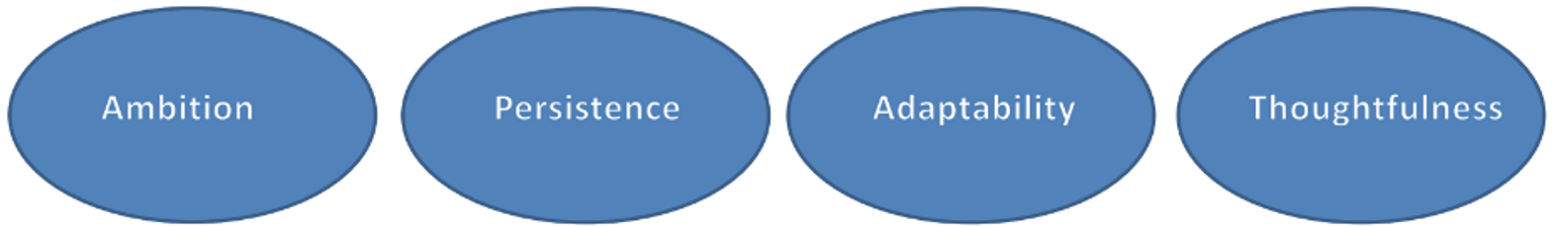

- to ignite a lifelong love of learning and equip children with skills and confidence to thrive in an ever changing world;
- to provide a safe and happy learning environment;
- provide high standards of teaching and learning in every class, by all staff members;
- to enable teachers and support staff to teach as effectively as possible;
- to understand the National Curriculum’s age related expectations for each year group;
- to understand each child’s attainment, progress and gaps in learning;
- to enable children to know and remember more;
- to give children the skills, knowledge and understanding they require to become confident, articulate and independent;
- to provide an inclusive education for all children;
- to appreciate British values and Christian beliefs;
- to provide a diverse curriculum that enables our children to develop a global perspective and better understanding of the world around them;
- to raise expectations for all pupils, to enable them to fulfil their full potential;
- to develop high levels of emotional intelligence to promote cooperation and collaboration in learning;
- to promote high standards of behaviour through clear expectations and by the example of the adults;
- to develop a clear sense of personal responsibility as a member of the school community and the Trust.
Teaching and learning in each school needs to be adaptable and focused on the needs of each group of pupils in each lesson. This policy outlines the key elements which are crucial to raising standards in teaching and learning, setting out a model structure for lessons based on best practice and research linked to how we learn effectively.
(See Appendix 2)

Evidence-Led Practice
At Amadeus we select our curriculum approaches for all subjects, with the implicit requirement that these have been built around evidence-led practice. This document summarises and directs the principles and practice that leads to excellence in the classroom. Whilst this may be through different approaches or schemes at each school, these must always be underpinned by:

Guiding research and evidence
- Sweller’s cognitive load theory
- Rosenshine’s principles of instruction guided by Cain and Oakhill’s vocabulary instruction
- Fiorella and Mayer’s generative learning practice
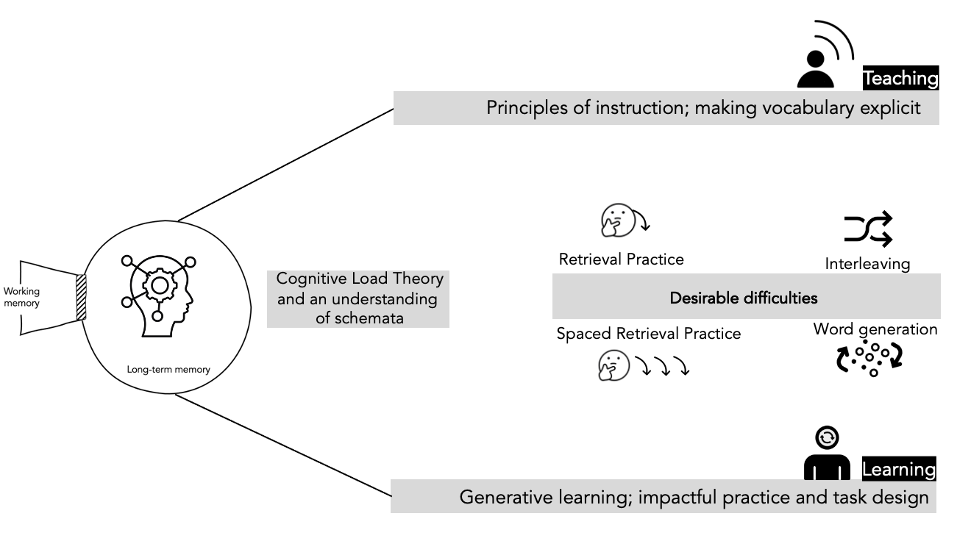

We believe that explicit vocabulary instruction must shape the structure and language provision throughout all curriculum areas as a golden thread that links and connects the breadth, depth and value of all units of teaching. At Amadeus language is a cornerstone in our overall approach to reduce social disadvantage and embedding learning.

Clare Sealy – Memory, not memories: https://primarytimery.com/2017/09/16/memory-not-memories-teaching-for-long-term-learning/

Vocabulary Mapping
At Amadeus, all schools are required to ensure that all subjects have a clear vocabulary sequenced lesson to lesson, including etymology and morphology as a minimum. This ensures that each schools approach goes beyond the National Curriculum, which specifies that vocabulary should be explicitly instructed, but does not give the finer level of detail necessary to ensure that instruction is progressive, systematic and meaningful.

School level curriculums must be underpinned by key language that is instructed within units, in all subjects. This ensures that pupils have the opportunity to learn and rehearse vocabulary in meaningful contexts, thus committing it to the long term memory.

Our Mastery Curriculum Approach
Our work towards ‘mastery’, is built through carefully consider curriculum design, pedagogy and assessment operating together to create a cohesive educational experience. Clare Sealy (see above) suggests that there are three main considerations in how learning is sequenced in a way that supports this:

- How much information is introduced
- The pace of introduction
- Opportunities for rehearsal and retrieval

At Amadeus therefore, sequencing of content for long-term learning must be central to our curriculum approach at every school. As a result, all Amadeus pupils who work through the curriculum journey at each school must be supported to develop both procedural and conceptual fluency.
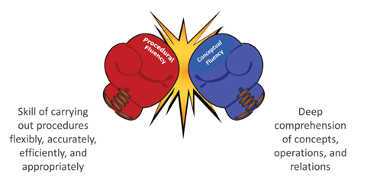

Each school’s curriculum must be structured to secure both procedural and conceptual fluency. Within each area, the deliberate retrieval and sophistication of content is planned so that pupils revisit and deepen their conceptual fluency, building on their procedural understanding.

Curriculum principles
- Our ambition is to erode deficits in cultural capital.
- Our priority is to improve teaching through evidence-led structure and practice, so that all children get great teaching.
- Our end goal is for all children to succeed, regardless of their starting points. Our curriculums therefore must be deliberately designed to give our children the tools and provision to know more and remember more.

Where schools use published schemes, these will have been selected to ensure that subjects have been built around a clearly defined set of curriculum drivers that infuse all subjects. Schools at local level, supported by the wider Trust team, will evolve these to ensure that the provision is successful in addressing needs within their own context and cohorts. For example, knowledge of the world may be a chosen as a driver because pupils have limited experiences beyond their own area.

Each school’s curriculum, will clearly define the content that pupils will learn, subject by subject. These are the headlines for each sequence. This will be structured as a cumulative curriculum, starting with EYFS provision, ensuring prior knowledge is always a pre-cursor to a single study. Teachers can then make skilful connections to prior knowledge as they are aware of the previous studies, over time.

Curriculum structure
To ensure this, prior learning should be mapped into every module to show and remind teachers of the previous provision pupils will have encountered. This enables teachers to orchestrate meaningful retrieval practice and connect past learning. This has an added benefit of giving new learning an organised place to be stored in the memory, and therefore retrieved.

In their long-term sequencing, schools should also deliberately plan to ensure that relevant inter-subject connections that complement each other are clear, for example, Rocks before Stone Age in a year group.

Where possible spaced retrieval practice should be incorporated to ensure areas of study are revisited, deepened and sophisticated. Some areas of the NC Science are very content heavy and as a result these need revisiting for clarification and sophistication, later in the year and time needs carefully planning in to sequences for this.

In all schools the English offer must be planned with a rich literature spine comprising ambitious texts that inspire and challenge pupils. This should be systematically mapped to enable children to experience breadth and depth of social, moral and ethical dimensions as well as a wide range of authors, matching the broad make-up of the school.

English
Where possible Writing should draw on taught content from the wider curriculum. Writing modules must be developed to provide teachers with the opportunity to teach and rehearse key knowledge and skills before applying this learning to meaningful extended outcomes. The careful architecture of this curriculum must ensure that pupils build on prior learning and maximise purposeful curriculum connections to become writers for life.

The whole school Reading strategy must be deliberately designed to be ambitious and aspirational, ensuring that every child leaves our schools as a competent, confident reader. Drawing on the latest research around explicit vocabulary instruction, reading fluency and key comprehension strategies, our curriculums must be a synthesis of what we know works in helping children make outstanding progress in reading and distil this into consistent, well-structured practice. Pupils will receive a consistent diet of excellent reading teaching and this will be supplemented by regular opportunities to engage with shared reading experiences, promoting the joy of reading with the whole school community. Whilst the whole school reading strategy may differ school to school, the clear structure and principles must ensure that teaching is progressive, challenging and engaging and the rich, diverse literature spine acts as both a mirror so that every child can see themselves in the core texts and as a mirror to engage pupils with experiences beyond their own field of reference.

The curriculum at Amadeus Primary Academies Trust will ensure that each schools resources support a knowledge-rich curriculum structure that is coherent and cumulative. Within this:

- Core knowledge is defined and articulated across subjects through a focused teaching sequence that is coherent, interleaved and built around spaced retrieval practice.

- At the start of every lesson the knowledge and vocabulary to be taught is clear. This may be through Knowledge notes, segments of Knowledge Organisers or through directed teaching (clear in short term planning) to support each lesson. This element of the lesson will be used to elaborate on the core concepts and content.

- Vocabulary is mapped across EYFS – Y6 for all subjects. It includes sequenced Tier 2 and Tier 3 words as well as etymology, morphology as a minimum for each learning module.

- Each study sequence is planned lesson by lesson using a centrally (school level) prescribed learning question or objective to focus the learning. Foundational knowledge is identified as an essential component within the sequence of learning.

- We use cumulative learning objectives or questions. These are designed to sequence each lesson and following teaching and practice to test the understanding of the taught content, lesson by lesson.

Whilst feedback /marking policies are set at school level, Trust thinking about how feedback can be used effectively within these sequences is informed by the Mark less, Mark better research, where feedback is used to reshape learning rather than just narrate outcomes. Assessment through observed practice, whole class marking strategies and cumulative quiz outcomes are encouraged across the Trust to inform teachers and children how well the content is understood, along with any misconceptions that need addressing. As a minimum, Feedback strategies must respond to incorrect lesson specific vocabulary and misconceptions. See Appendix 3

https://assets.website-files.com/60ae1aa7637f8ec801c3e7fa/60faad990650d95e6def6ee6_mark-less-mark-better-autumn-2019.pdf

- Subject leaders’ quality assures learning by observing teaching and quality assuring books, but with a priority of talking with a varied group of pupils using their books to explain how well they know, can use and connect learning. The process is underpinned by Pupil Book Study – a structured and evidence-led guide to quality assuring the curriculum, teaching and learning by Alex Bedford.

- Where beneficial technology supports teaching and learning through the use of devices in the classroom to enhance the teaching and learning practice. We do not encourage unguided / unplanned discovery research using iPads or laptops at the beginning of a learning sequence. This will only increase the load on the working memory and be counter-intuitive.

- Pupils’ books are repurposed, so they become more than just a place to collect completed work from a lesson. Pupils’ books, supported by resources at school level should be developed so they are used to engage children in a variety of teacher-led, guided and independent tasks to help them generate, build on and connect prior learning, with the book as a retrieval tool.

- When developing the curriculum towards short term planning, task design must specifically take account of the need to build pupils’ conceptual fluency. By building pupils’ confidence and competence in tried and tested learning approaches, we can refocus their cognitive capacity to the most important thing – the content that they are learning. An example of this could be the use of an organisational Venn diagram in multiple contexts. At first it could be used for example to categorise Animals, including humans in early KS1 and then later in the sequence, through spaced retrieval practice, children could compare and contrast Animals, including humans, using the same diagram. Likewise, pupil should meet similar response frameworks throughout for example Reading units for skills such as retrieving facts to complete a table or sequencing events from a narrative and this will allow them to approach this task in the context of ever-more challenging texts.

Teaching and Learning
Excellent teaching is built around coherent and cumulative curriculum structures. Central to the structure is the evidence-led practice that reflects the strong curriculum offer. The curriculum structure directly supports excellent teaching and learning.

To support excellent teaching, we underpin our expectation of great teaching with Alex Bedford’s Five Point Provision:

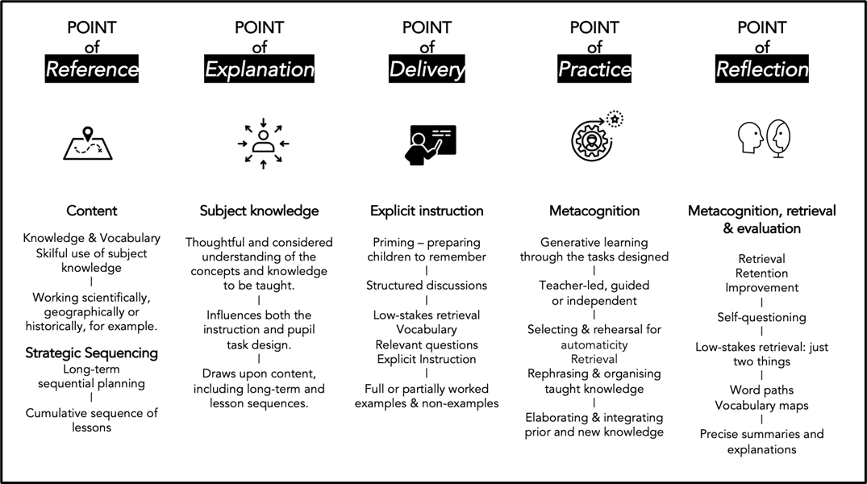

- Teachers use resources such as CUSP as the POINT OF REFERENCE.

- The resources directly support the point of explanation. This means that teachers understand the subject knowledge and are able to explain it in multiple ways, which leads to thinking carefully about task design.

- Clear connections between past, present and planned future learning are considered by teachers.

- Explicit instruction techniques are used at the point of delivery, where teachers model and explain foundation concepts and knowledge.

- Carefully designed knowledge notes, organisers or clear sections in short term planning must underpin the point of practice, ensuring clarity of what we want children to know and remember from each lesson. Pupils are expected to draw upon prior learning - this could be from the last lesson or from the last term.

At Amadeus we believe that great teachers use professional and evidence-led understanding along with a wide range of tools articulated in teaching toolkits. Typically, teachers have autonomy about when and how they deploy and use these tools within lessons. The areas below form the basis of our teaching toolkit, informed by evidence-led practice.
(See more detail in Appendix 1)

Connections:

Curriculum long and medium-term sequences position knowledge coherently and cumulatively.
|
Prior knowledge is made obvious to position new or abstract content.
|
The bigger picture of the study is deliberately brought to the attention of children.
|
Teachers articulate how content is related and connected by moving between the big
ideas and today’s focus knowledge.

Vocabulary:

Explicit vocabulary instruction of Tier 2 and Tier 3 words. Teach a few words regularly and use them all the time.
|
Use vocabulary on working walls and incorporate into pupil practice to remember and connect meaning.
|
Teach etymology and morphology of words help to unwrap meaning. This makes sense of vocabulary in context, helps pupils acquire a deeper understanding and unlocks thousands of other words.
|
Vocabulary on maps or working walls help construct long-term memories through oral rehearsal and conscious use.

Explanations and Worked Examples:

Where relevant, prior knowledge is clearly referenced and
brought to the attention of pupils, so they can think about it.
|
Lesson questions or objectives are posed / used, drawing upon prior knowledge.
|
Fully worked examples are clearly modelled when knowledge is new.
|
Partially worked examples are used to build upon knowledge
which has been taught.
|
Resources clearly supporting explanations, including high quality books, maps, images, atlases, globes, diagrams and video (if appropriate).
|
My turn, our turn, your turn mastery techniques are used to support guided and independent practice.
|
Pupils have resources to support independent practice.

Retrieval Practice:
Techniques used to support retrieval practice, include:
|
Developing cumulative questions or low stakes testing into each lesson sequence to be used diagnostically.
|
Using end of unit assessments to summarise what children know and can retrieve.
(This is useful as a retention record and for future use.)
|
Using retrieval checks to help children show what they know at the start of each lesson
|
Using word connections maps and adapted explanations to support pupils to draw on prior knowledge.
|
Knowledge is compared and contrasted through structured organisational diagrams or explanative diagrams.
|
Self questioning strategies increase the retrieval of taught knowledge using question and statement stems.

Spoken Language:

Vocabulary is live modelled with attention paid to the phases of vocabulary acquisition:
|
Vocabulary promotes the level of ambition across the curriculum through precise disciplinary literacy.
|
In lessons pupils define, decode, use, connect, deconstruct and analyse.
|
Oral modelling and rehearsal.
|
A variety of models are used to affect the impact of oracy, including rote and recitation techniques, instruction, discussion and dialogue.

Self-Regulation (Metacognition):

Self-regulation is made visible through clear modelling.
|
Resources that guide and instruct are used by pupils to plan, monitor and evaluate their own learning.
|
Pupils evaluate their studies through self-regulation techniques such as flick-back techniques (using prior learning in books for retrieval), marking up on knowledge organisers, knowledge notes or wider resources.
|
Early in lessons children are directed to make cross-subject connections drawing on current and new understanding.

Classroom Strategies:

Pupils know and use examples from live modelling – My turn.
|
Children can explain what examples / resources are for and how they help.
|
Vocabulary, diagrams and explanations are modelled and clearly accessible.
|
Vocabulary connections maps, explanative or organisational drawings help pupils make sense of knowledge taught.
|
High quality books and images create a sense of wonder, for example, and curiosity.
|
World maps, newspaper articles, and events bring items in the news, for example, to the attention of pupils.

Assessment: How well pupils know and can apply learning:

Formative assessment (lesson to lesson and in lesson) draws upon a range of tools that help pupils and teachers know where learning is strong and where misconceptions lie.
|
Questions around the key knowledge of each lesson frame the lesson content. These are designed to act as a hinge for testing out how well pupils know and can use current learning and connect to prior learning.
|
As a result of formative and summative assessment, post- or pre-teaching is planned to close any knowledge gaps.

APPENDIX 1:
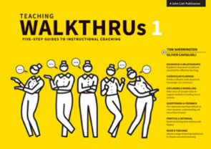

The ‘Teaching Walkthrus’ give further examples and practical guidance. These match our key areas of classroom practice above:

 | P26 – 27  P50 – 51 | P54 – 59  P62 – 63
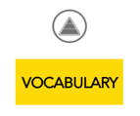 | P26  P54 – 55 | P60 – 61  P72 – 73  P103 – P104
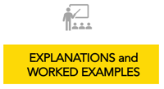 | P52 – 53  P68 – 71 | P76 – 81  P116 – 117  P124 - 131
 | P20 – 23  P27 | P82 – 87  P124 - 131
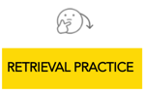 | P68 – 75 | P82 – 87  P112 - 117
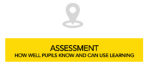 | P28 - 29 | P94 – 95  P96 – 99  P104 – 109  P120 - 123
 | P90 - 93 | P96 – 99  P118 – 119  P120 - 121
 | P30 – 31 | P36 - 47
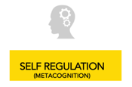 | P27  P82 - 87

APPENDIX 2: Model of Teaching and Learning

This is a model of how the Trust Curriculum, Teaching and Learning Policy could be delivered in practice, however this would look different in every classroom, based on topic, prior knowledge and links, the cohort and assessment for learning information.

This should be looked at alongside the policy, the school level curriculum and the research which underpins it.

CONNECT 1:
Retrieval Practice Task

CONNECT 2:
Where appropriate make links to prior learning (Units in other Years / Subjects)

EXPLAIN:
Teacher Instruction - What I want you to know and remember and be able to do (skill) today and Discrete Vocabulary Teaching - highlight possible misconceptions

EXAMPLE 1:
Teacher Modeling: Use worked examples, diagrams, images, video etc and minimal slides to explain key knowledge. Some groups may move straight to task before or after this.

EXAMPLE 2:
Shared Practice: My Turn / Your Turn Some groups may move straight to task after this.

ATTEMPT:
Check for Understanding by setting a short rehearsal task to aid children in making sense of learning. Some groups may move straight to task after this.

Teacher Modelling (As needed):
Set expectations of adapted tasks - reminding children to apply vocabulary and remind of misconceptions

APPLY:
Independent Tasks - Using / Applying Knowledge. CT live marks focused on Key Vocabulary / Misconceptions. This is an opportuity to check for understanding / extend any group that started early.

CHALLENGE:
Use of Questions / Tasks to check ability to retrieve key knowledge

APPENDIX 3: Learning Analysis Sheet
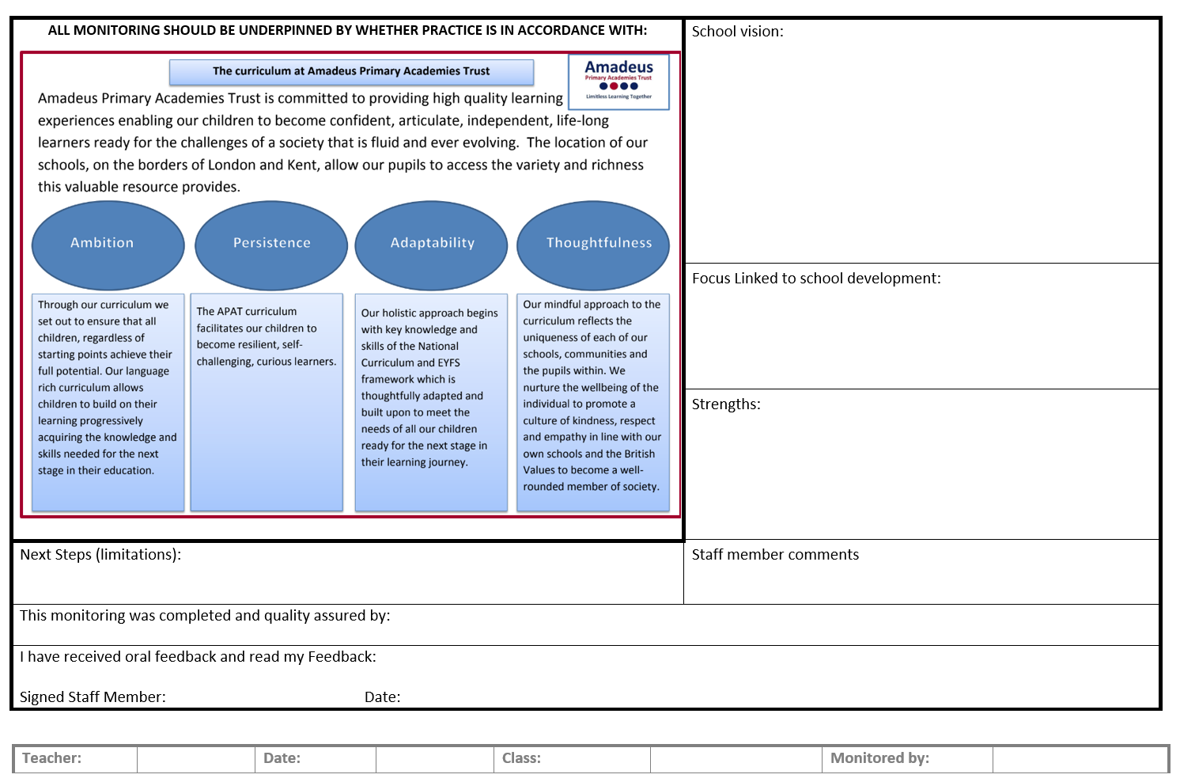

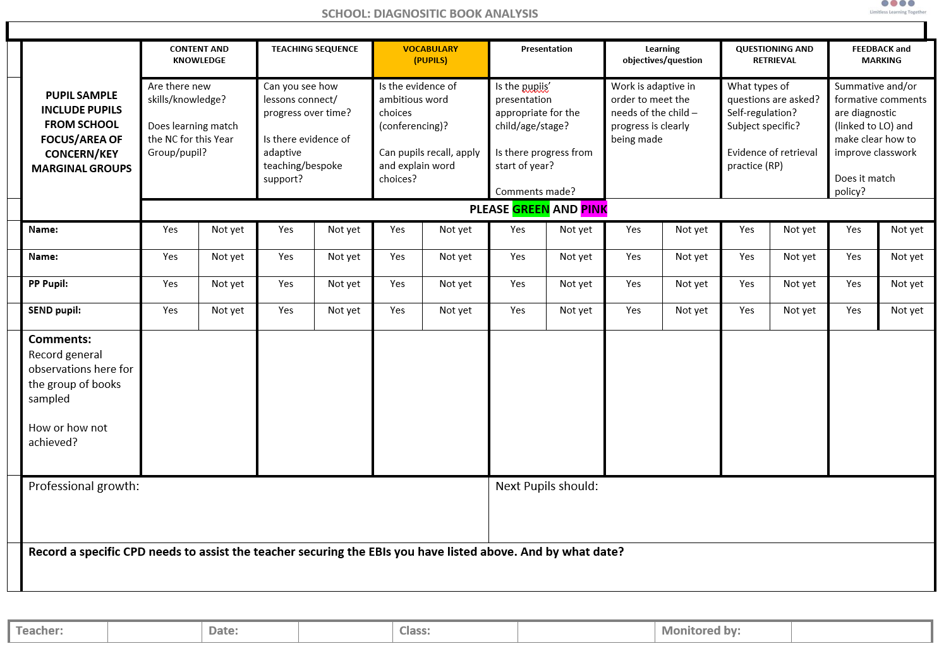

APPENDIX 4: Glossary

Glossary of terms:

Cognitive load - Cognitive load refers to the amount of information our working memory can process at any given time. For educational purposes, cognitive load theory helps us to avoid overloading learners with more than they can effectively process into schemas for long-term memory storage and future recall.

Cultural capital - the essential knowledge that children need to be educated citizens

Etymology - the study of the origin of words and the way in which their meanings have changed throughout history. The origin of a word and the historical development of its meaning.

Interleaved – the sequencing of tasks/learning and purposeful revisiting of subjects to make connections

Metacognition - awareness and understanding of one's own thought processes.

Morphology - Morphology is the study of words and their parts. Morphemes, like prefixes, suffixes and base words, are defined as the smallest meaningful units of meaning. Morphemes are important for phonics in both reading and spelling, as well as in vocabulary and comprehension.

Pedagogy - the method and practice of teaching, especially as an academic subject or theoretical concept.

Retrieval (practice) - Retrieval practice is a strategy in which bringing information to mind enhances and boosts learning. Deliberately recalling information forces, us to pull our knowledge “out” and examine what we know.

Return to Aims

APPENDIX 5: Cognitive Load Theory
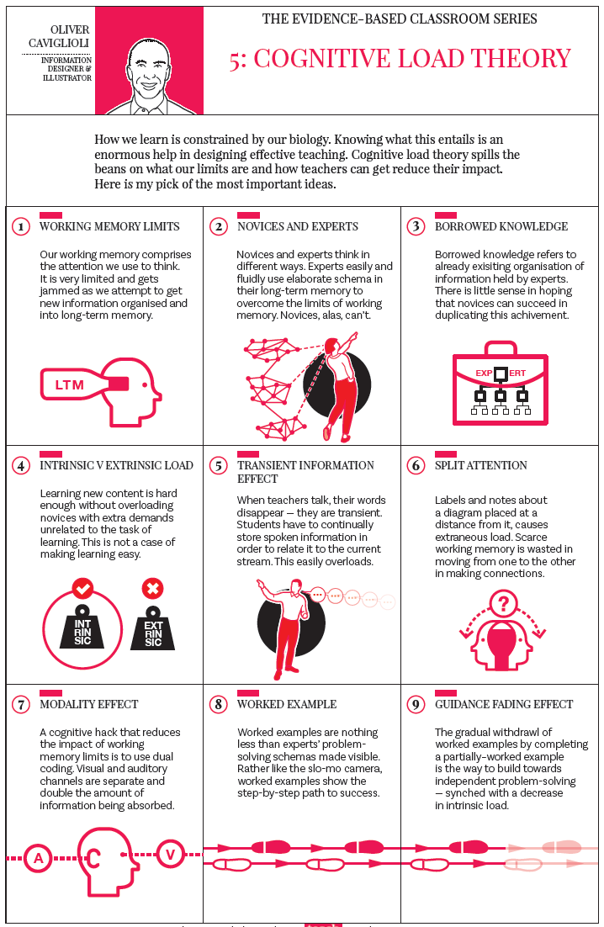

APPENDIX 6: Rosenshine’s Principle

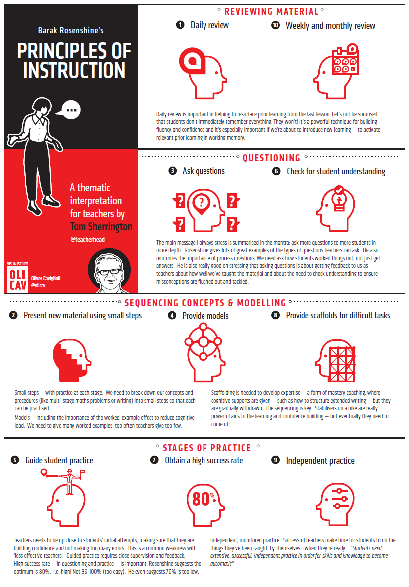

APPENDIX 7: Generative Learning Practice


